**Concepts of Cloud computing**

**Cloud computing** is the on-demand availability of [computer](https://en.wikipedia.org/wiki/Computer) [system resources](https://en.wikipedia.org/wiki/System_resource), especially data storage ([cloud storage](https://en.wikipedia.org/wiki/Cloud_storage)) and [computing power](https://en.wikipedia.org/wiki/Computing_power), without direct active management by the user. Large clouds often have functions [distributed](https://en.wikipedia.org/wiki/Distributed_computing) over multiple locations, each of which is a [data center](https://en.wikipedia.org/wiki/Data_center). Cloud computing relies on sharing of resources to achieve coherence and typically uses a "pay as you go" model, which can help in reducing [capital expenses](https://en.wikipedia.org/wiki/Capital_expenses) but may also lead to unexpected [operating expenses](https://en.wikipedia.org/wiki/Operating_expense) for users.

**Cloud platforms and their role in Enterprise systems**

**What is Enterprise Cloud?**

Enterprise cloud is a computing model where businesses can access virtualized IT resources from a public or private cloud services provider on a pay-per-use basis. These resources can include servers, processing power (CPU cores), data storage, virtualization capabilities, and networking infrastructure.

Enterprise cloud computing creates new opportunities for businesses to reduce costs while enhancing business resiliency, flexibility, and network security.

As organizations undergo digital transformation, they need flexible and scalable access to three types of computing resources: processing power, computer memory, and data storage. In the past, these organizations would bear the cost of implementing and maintaining their own networks and data centers. Now, enterprises can access these resources at a low cost by partnering with public and private enterprise cloud service providers.

**Why are Enterprises Moving to the Cloud?**

**1. Cost savings** – a typical enterprise cloud solution leverages pay-as-you-go pricing, so businesses only pay for the resources they use. In addition, businesses that move to the Cloud can avoid many or all of the up-front costs of developing similar capabilities in-house. There’s no need to lease a data center, no servers to buy, and no physical computing infrastructure that needs to be maintained. As a result, IT expenses for enterprise cloud adopters are often lower, easier to calculate, and easier to predict.

**2. Security** – enterprise organizations are frequently targeted by cyber criminals wishing to steal or expose data. Data breaches are extremely costly to remedy and can negatively impact your reputation and customer relationships. With enterprise cloud, organizations can access security tools like system-wide identity/access management and cloud security monitoring. They can easily implement network-wide identity and access controls. Cloud service providers also play a role in supporting data security in public and private deployments.

**3. Disaster Recovery/Business Resiliency** – Without a solid Disaster Recovery solution, business resiliency is at risk in the face of a service outage, natural disaster, or cyberattack. Lost revenue, degradation of customer trust, and even bankruptcy are possible outcomes.

Consider what happened to Delta Air Lines: On August 8th, 2016, the airline company experienced a power outage at its operations center in Atlanta. Delta’s disaster recovery protocols failed and core travel booking systems were offline for more than five hours. As a result, Delta was forced to cancel 1,500 flights, delay another 1,800, and issue thousands of refunds and travel vouchers for customers. The total price tag for the 5-hour power outage was in excess of $150 million.

Faction’s Hybrid-Disaster-Recovery-as-a-Service (HDRaaS™) is our own trademarked solution for enterprise [disaster recovery](https://www.factioninc.com/blog/cloud-disaster-recovery/) that’s powerful, cheap and fully managed. We provide non-disruptive recovery testing, reliable back-up data storage, and we manage the disaster declaration and failover process. Companies like Delta Air Lines can use disaster recovery services to recover more quickly from service outages and avoid revenue disruption.

**4. Flexibility & Innovation** – Enterprise cloud computing offers businesses the flexibility to dynamically scale their resource consumption up or down as needed. This minimizes the amount of upfront capital cost associated with launching a new product or testing a new service and removes barriers to innovation.

**Core Concepts — Types of Cloud: Private, public, and Hybrid clouds.**

# **What is a Private Cloud?**

**A private cloud is an on-demand cloud deployment model in which the cloud computing services and infrastructure are hosted privately within a company’s own intranet or data center using proprietary resources.**

A **Private Cloud** is a model of [cloud computing](https://www.vmware.com/topics/glossary/content/cloud-computing-infrastructure.html) where the infrastructure is dedicated to a single user organization. A private cloud can be hosted either at an organization’s own [data center](https://www.vmware.com/topics/glossary/content/data-center.html), at a third party colocation facility, or via a private cloud provider who offers private cloud hosting services and may or may not also offer traditional public shared multi-tenant cloud infrastructure.

Typically, the end-user organization is responsible for the operation of a private cloud as if it were a traditional on-premises infrastructure, which includes ongoing maintenance, upgrades, OS patches, middleware, and application software management.

Private Cloud Solutions offer organizations more control over and better security of private cloud servers, although it does require a much higher level of IT expertise than utilizing a public cloud.

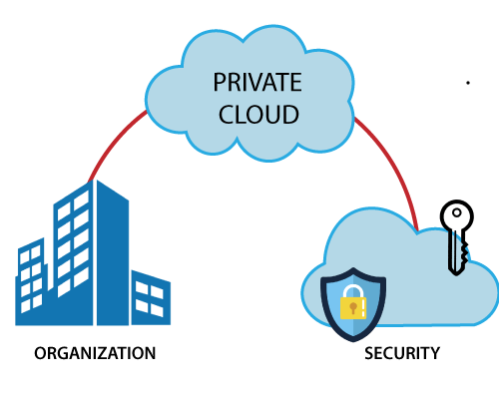

**How Private Cloud Works**

Today, businesses are moving to cloud for their most critical business applications. It is an excellent way to deliver IT services more quickly and cost-effectively. When looking for a secure cloud option, organizations often choose private clouds. Although businesses were a little reluctant to migrate to private cloud earlier, it quickly emerged as the most secure cloud model.

Among the three types of cloud computing, private cloud is the most preferred option for organizations due to the additional security it offers. In a private cloud, the cloud computing services and infrastructure are hosted privately within a company’s own data center. These services are accessible to the personnel of a single organization. This type of cloud is managed by internal resources and is not accessible to those outside the organization. Private clouds are also referred to as enterprise clouds.

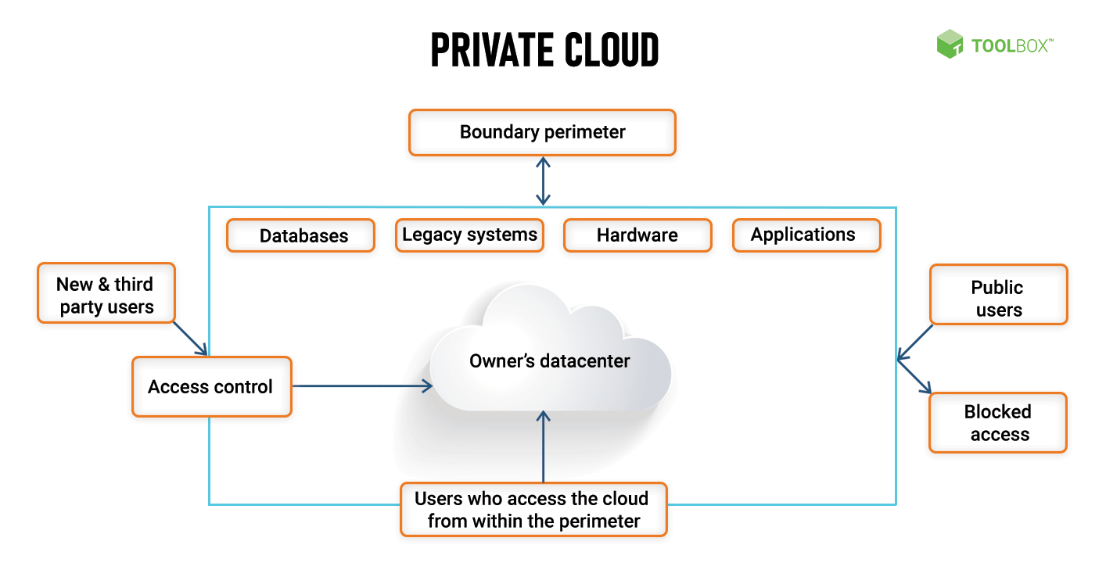

## Types of Private Cloud

Depending on who manages the private cloud environment and where the cloud solution is hosted, a private cloud can be classified into four major types – virtual private cloud, managed private cloud, hosted private cloud, and on-premise private cloud. Let’s look at each one in detail.

### 1. Virtual private cloud

A virtual private cloud (VPC) is a type of cloud model that offers the benefits of a private cloud (more control and an isolated environment) with the help of [public cloud resourcesOpens a new window](https://it.toolbox.com/tech-101/what-is-public-cloud-learn-the-basics-of-aws-google-ibm-microsoft-azure-and-oracle-cloud). Although private cloud and virtual private cloud are often used interchangeably, there are many points of difference between the two.

In a traditional private cloud, a company’s internal IT department acts as the service provider, and the individual business units act as tenants. In a virtual private cloud model, a public cloud provider acts as the service provider, and the cloud users act as its tenants. Simply put, a virtual private cloud is a hybrid model of cloud computing in which a private cloud solution is provided within a public cloud provider’s infrastructure.

### 2. Managed private cloud

A managed private cloud is a type of private cloud model in which the infrastructure is not shared. It is also referred to as a dedicated or single-tenant cloud. This type of private cloud is managed by a third-party vendor. The vendor provides support, maintenance, upgrades, and even remote management of the private cloud. In some cases, vendors also manage the software applications in cloud.

### 3. Hosted private cloud

Hosted private cloud vendors offer cloud servers in their own data centers and are also responsible for security management. In a hosted private cloud model, users get access to additional resources, a support team, high-demand scalability options, as well as a user-friendly dashboard to assist in server management.

### 4. On-Premise private cloud

Unlike hosted private clouds, on-premise cloud solutions allow users to host a cloud environment internally. For such a cloud model, it is necessary to have an internal data center to host the cloud server. This type of private cloud model is very secure as they are internally hosted and managed by an organization’s internal IT department. The organization, therefore, has complete control over the security, configurations, and scalability of its servers.

## Examples of Private Cloud Providers

Let’s glance at the services provided by some leading private cloud vendors.

### 1. HPE

Hewlett Packard Enterprise (HPE) has been a leader in the private [cloud computingOpens a new window](https://it.toolbox.com/tech-101/the-top-5-cloud-computing-books-to-read-in-2019) market for many years. The private cloud service provider offers customizable private cloud software and infrastructure. The HPE private cloud can be used along with a public cloud to provide a faster connection with the same security protections as a private cloud. HPE’s private cloud offerings include services, hardware, and software. Its private cloud solutions include the Helion CloudSystem hardware, Helion Cloud Suite software, Helion Managed Private Cloud, and Managed Virtual Private Cloud services, among others.

### 2. VMware

VMware offers two types of private cloud solutions. While one solution is completely private, the other is a hybrid solution that offers an integrated stack as well as automated lifecycle management. Although VMware is best known for its [virtualization software](https://www.spiceworks.com/tech/cloud/tech-101/virtualization-in-cloud-computing-hardware-software-desktop-data-more/) that runs many private cloud environments, it also offers a variety of other services. VMWare’s vRealize Suite Cloud Management Platform offers private as well as hybrid cloud management. The VMWare Cloud Foundation, on the other hand, is a data center platform for private clouds.

### 3. Dell

Dell EMC offers two private cloud products. While one is meant for [Microsoft Azure Stack](https://www.spiceworks.com/tech/storage/tech-101/common-aws-services-explained-ec2-rds-s3-vpc/), the other is a turnkey developer platform. Dell, who was always a leader in the private cloud market, became an even stronger player after its merger with EMC. The company’s cloud offerings include cloud management and cloud security software, virtual private cloud services, and various cloud consulting services.

### 4. Oracle

Oracle’s Private Cloud Appliance is a scalable data center that is capable of processing mixed workloads. The company’s private cloud solutions include its cloud platform, [infrastructure](https://www.spiceworks.com/tech/it-infrastructure/articles/what-is-it-infrastructure/), applications, lifecycle management tools, as well as integration services, along with managed cloud services.

### 5. IBM

The design of the IBM private cloud is based on open source frameworks, including Kubernetes and Cloud Foundry. The company’s private cloud solutions include IBM Systems and IBM Storage, IBM Cloud Managed Services, Cloud Manager, and Cloud Orchestrator. Apart from the private cloud vendors mentioned above, Microsoft, Cisco, NetApp, Red Hat, and AWS are also major players in the private cloud race.

## Advantages and Challenges of Private Cloud

Although a private cloud is quite expensive, it comes with its share of **advantages**. Let’s look at the various benefits that a private cloud offers:

* + **Robust security:**Private cloud is known for enhanced security and control. Since a private cloud can be operated in a completely isolated environment, it offers an additional layer of security.
  + **Enhanced performance:** A private cloud is only accessible to one organization. This results in lesser competition for capacity, and therefore, improved performance. Therefore, the workload performance for private cloud is never affected by another organization running resource-intensive workloads on a shared server.
  + **Complete control over resources:**When using a private cloud, an organization is free to build and configure cloud services in a way that’s most suitable to the company’s needs. Not only can you use the [applications](https://www.spiceworks.com/security/data-security/articles/top-10-application-security-tools-2020/) of your choice, but you may also allocate resources as per business needs.

A private cloud is very secure, no doubt. However, managing a cloud internally can prove to be quite challenging. Here are some other **challenges**organizations face with private clouds:

* + **Added cost:**Private clouds are more expensive than public and hybrid clouds because they require the organization to pay for private cloud server hardware as well as maintenance. Buying the operating systems and licenses for [software applications](https://www.spiceworks.com/it-security/network-security/articles/top-10-firewall-software-for-desktops/) further increases the cost.
  + **More support requirements:** Setting up a private cloud is a lot more expensive and time-consuming than a hybrid or public cloud. It also needs continuous maintenance. A private cloud service requires an in-house IT setup. Moreover, if your server crashes, your internal IT department will have to spend more time and resources to fix the issue.
  + **Limited scalability:** The private cloud is not as scalable as the public cloud. If the need arises, an organization may not be able to handle higher workloads when using a private cloud.

## Why use Private Clouds?

Private Clouds offer the same control and security as traditional on-premises infrastructure. Here are some reasons why organizations opt for private cloud computing:

* **Security**: Private cloud security is enhanced since traffic to a private cloud is typically limited to the organization’s own transactions. Public cloud providers must handle traffic from millions of users and transactions simultaneously, thus opening a greater chance for malicious traffic. Since private clouds consist of dedicated physical infrastructure, the organization has better control over the server, network, and application security.

* **Predictable performance**: Because the hardware is dedicated rather than multi-tenant, workload performance is predictable and unaffected by other organizations sharing infrastructure or bandwidth.

* **Long-term savings**:  While it can be expensive to set up the infrastructure to support a private cloud, it can pay off in the long term. If an organization already has the hardware and network required for hosting, a private cloud can be much more cost-effective over time compared to paying monthly fees to use someone else’s servers on the public cloud.

* **Predictable costs**: Public cloud costs can be very unpredictable based on usage, storage charges, and data egress charges. Private cloud costs are the same each month, regardless of the workloads, an organization is running or how much data is moved.

* **Regulatory governance**: Regulations such as the EU’s GDPR may dictate where data resides and where computing occurs. In those regions where public cloud providers cannot offer service, a private cloud may be required. Additionally, organizations with sensitive data such as financial or legal firms may opt for private cloud storage to ensure they have complete control over personally identifiable or sensitive information.

# 

# **What is a Public Cloud?**

**Public Cloud** is an IT model where on-demand computing services and infrastructure are managed by a third-party provider and shared with multiple organizations using the public Internet. Public cloud service providers may offer cloud-based services such as infrastructure as a service (IaaS), platform as a service (PaaS), or software as a service (Saas) to users for either a monthly or pay-per-use fee, eliminating the need for users to host these services on site in their own [data center](https://www.vmware.com/topics/glossary/content/data-center.html).

Cloud service providers use groups of data centers that are partitioned into [virtual machines](https://www.vmware.com/topics/glossary/content/virtual-machine.html) and shared by tenants. Tenants may simply rent the use of those virtual machines, or they may pay for additional cloud-based services such as software applications, application development tools, or storage. Companies often use public cloud services for less-sensitive applications that have unpredictable spikes in usage or for storing data that does not require frequent access.

Public cloud makes computing resources available to anyone for purchase. Multiple users typically share the use of a public cloud. In contrast, private cloud involves cloud-based services that are hosted within an organization’s own private servers.

## Why Public Cloud?

Many enterprise businesses look to public cloud as a way to scale existing IT resources on demand without committing to expanding their physical IT infrastructure. For instance, instead of purchasing a physical desktop machine, a company can purchase a [virtual desktop](https://www.vmware.com/topics/glossary/content/virtual-desktops.html) license. The virtual desktop can be spun up or deactivated in minutes and can be located anywhere, instantly.

The public cloud is also a popular solution for storage needs since data stored on a public cloud is backed up and accessible from anywhere. There are many different types of storage plans, and data that does not need to be accessed frequently can often be stored in the public cloud very cheaply.

For companies that host an application with periods of peak usage, the public cloud makes perfect sense because the extra computing power is only needed for a short time.

Using the public cloud can save businesses money in a couple of different ways:

**Lower equipment purchase costs**: Because employees can access and pay for cloud-based resources only when they need them, using public cloud–based desktops and applications is often less expensive than purchasing physical IT equipment or software packages that may or may not be used and will need to be maintained.

**Lower equipment maintenance costs**: With public cloud-based services, the cost of maintaining IT equipment is also passed on to the cloud service provider.

A small or new business may have an easier time migrating applications to the public cloud; organizations with a large legacy IT infrastructure and applications have more to consider and plan for. However, more and more enterprise businesses are moving toward public cloud as one element of a multi-faceted IT plan. This way, they can access the benefits of public cloud while also maintaining the different benefits that come with on-premises architecture and private cloud options.

## 

## Definition of Public Cloud

Public cloud is a cloud deployment model where computing resources are owned and operated by a provider and shared across multiple tenants via the Internet.

## How Public Cloud works

A public cloud relies on a virtualized environment to provide an extension of a company’s IT infrastructure, allowing that company to host certain aspects of its infrastructure and services on virtual servers that are offsite and owned by a third party. Public cloud service providers have different strengths, and they offer a wide variety of services and pricing models. Companies that are considering a migration to public cloud need to carefully consider their options when it comes to choosing a provider, especially if they will be locked into a long-term contract. Careful planning can help to keep costs down on monthly cloud services bills, but organizations with unpredictable public cloud usage may find it hard to avoid spending a lot of money on public cloud services when usage suddenly surges.

Because servers in the public cloud share data from multiple companies, security in public cloud is another issue that IT managers will want to weigh. Encrypting data is a good way to ensure stronger security, but if you are using a combination of public and private cloud (also known as a hybrid cloud), not all encryption platforms work across both public and private clouds. There is also an inherent security risk whenever data is moved between a private data center or private cloud and a public cloud.

One last consideration is the location of your public cloud service provider. Data privacy laws in many countries require certain types of data to be stored in-country. These laws change frequently, so it’s a good idea to choose a cloud service provider that is located in your country and can confirm that the servers where your data will be stored are local and in compliance with regional laws. There is also the issue of latency—if your data is being hosted on a different continent, it may take longer than if it were stored close by.

# What is a Hybrid Cloud?

A hybrid cloud is a mixed computing environment where applications are run using a combination of computing, storage, and services in different environments—public clouds and private clouds, including on-premises data centers or “edge” locations. Hybrid cloud computing approaches are widespread because almost no one today relies entirely on a single public cloud.

Hybrid cloud solutions enable you to migrate and manage workloads between these various cloud environments, allowing you to create more versatile setups based on your specific business needs. Many organizations choose to adopt hybrid cloud platforms to reduce costs, minimize risk, and extend their existing capabilities to support digital transformation efforts.

A hybrid cloud approach is one of the most common infrastructure setups today. Cloud migrations often naturally lead to hybrid cloud implementations as organizations often have to transition applications and data slowly and systematically. Hybrid cloud environments allow you to continue using on-premises services while taking advantage of the flexible options for storing and accessing data and applications offered by public cloud providers, such as Google Cloud.

[Get started for free](https://console.cloud.google.com/freetrial)

## Hybrid cloud defined

Hybrid cloud solutions include applications, or their components such as compute, networking, and storage, when deployed across public and private clouds. On-premises servers are also often referred to as private clouds.

## Hybrid cloud examples

The most common hybrid cloud example is to use public cloud with private cloud services and on-premises infrastructure. However, there’s no one hybrid cloud configuration or one-size-fits-all architecture.

A hybrid cloud could combine a public cloud and a private cloud running on-premises or on the edge. It could also combine a public cloud with another public cloud (a.k.a., multicloud).

Hybrid models are meant to allow an organization to mix and match environments and to choose what works best for the specific applications and data. For instance, hybrid solutions are popular with companies in highly regulated industries that have strict data privacy requirements for how they store, process, and interact with their data.

Another common example is adopting a hybrid cloud approach when transitioning to using a public cloud to scale capacity dynamically when computing or processing demands exceed a data center’s capabilities. Many cloud migration projects inevitably lead to hybrid cloud deployments as workloads and applications are slowly and strategically shifted over to the cloud.

### **Is hybrid cloud the same as multicloud?**

While these terms are often used interchangeably, they are not in fact the same. Hybrid cloud features different interconnected public and private clouds working together, sharing data and processes to perform the same task. On the other hand, [multicloud](https://cloud.google.com/learn/what-is-multicloud) approaches use services from more than one public cloud to perform various tasks, regardless of where they are hosted. Organizations that do not want to depend on a single cloud provider may choose to use resources from several providers to get the best benefits from each unique service.

A hybrid cloud approach can also be considered multicloud if it includes resources from a private cloud and resources from at least two public cloud service providers. In other words, multicloud setups include hybrid cloud setups but a hybrid cloud is not automatically considered multicloud.

## How does a hybrid cloud work?

Hybrid clouds work by combining the resources and services from two or more separate computing environments. Hybrid cloud architectures require integration, orchestration, and coordination so you can share, shift, and synchronize information quickly.

Strong hybrid cloud networking is critical for a hybrid cloud deployment to function correctly. Interconnectivity between environments is typically established using a local area network (LAN), wide area network (WAN), virtual private network (VPN), and application programming interfaces (APIs).

Similar to other cloud computing architectures, hybrid cloud platforms leverage virtualization, containerization, and software-defined networking and storage technologies to abstract and aggregate resources. Dedicated management software allows organizations to allocate resources and enable on-demand provisioning to different environments.

## What is a hybrid cloud approach used for?

A hybrid cloud approach is suited for you if you want to take advantage of the scale and security of a public cloud, such as Google Cloud, while keeping your data on-premises to comply with data residency laws or supporting computing needs closer to your customers. For some of you, with critical systems operating in private and public clouds, hybrid computing is a great option.

Here are just a few examples of the benefits of adopting a hybrid cloud:

* **Modernize at your own pace.**With a hybrid cloud you can migrate applications to the cloud at the pace that makes sense for your business and transform your technical infrastructure over time.
* **Maintain regulatory compliance.**Many industries have rules surrounding where your app can operate. Hybrid can help you use private and public clouds while adhering to any regulatory requirements.
* **Running apps on-premises.**You may have regulated applications that need to remain on-premises or mainframe systems that are difficult to move to the cloud.
* **Running apps at remote edge locations.** If you are operating in industries that demand edge hybrid computing for low latency, such as kiosks in retail or networks in telecom, a hybrid approach lets you run select apps at the edge.

## Hybrid cloud solutions

Today, IT teams are looking to architect hybrid cloud environments that make use of the same technology stacks to keep pace with the adoption of cloud-native technologies, microservices and container-based architecture, and infrastructure as code.

Over time, hybrid cloud solutions have become less focused on interconnectivity between locations and increasingly shifted towards workload portability and automated deployment to the most optimal environment for the business use case.

Therefore, we recommend thinking about hybrid cloud platforms based on what they do, rather than solely in terms of location and ownership.

A hybrid cloud solution should:

* Consolidate IT resources, services, and functionality
* Automate scale-out and provisioning
* Move workloads freely between environments
* Orchestrate processes and provide unified management
* Automate deployment of applications in both private and public clouds, as well as edge locations

## What are hybrid cloud benefits?

### **Effective application governance**

A hybrid approach allows you to decide where your application sits and where hybrid computing happens. This can help improve privacy and ensure compliance for your regulated applications.

### **Improved performance and reduced latency**

Sometimes, distributed apps at remote locations benefit from a hybrid cloud solution. For applications with low latency requirements, hybrid computing happens close to the end users.

### **Flexible operations**

Hybrid computing gives you the flexibility to operate in the environment that’s best for you. For example, by building with [containers](http://cloud.google.com/containers), you can create portable applications and easily move between public and private clouds.

### **Improved ROI**

By adding a public cloud provider to your existing on-premises infrastructure, you can expand your cloud computing capacity without increasing your data center expenses.

### **Improved performance and reduced latency**

Sometimes, distributed apps at remote locations benefit from a hybrid cloud solution. For applications with low latency requirements, hybrid computing can happen closer to the end users.

### **Faster innovation**

Hybrid cloud models provide access to the latest technologies like AI and machine learning without having to extend or replace your existing infrastructure. You can maximize resources and increase productivity to speed up the development and delivery of apps.

## Hybrid cloud disadvantages

While hybrid cloud deployments offer many advantages, it may not be the right fit for your organization.

Since hybrid cloud models include the use of private cloud and on-premises infrastructure, you still have to invest and maintain in-house hardware and any additional software and tools needed. Hybrid cloud adoption often requires new technical expertise from both IT teams as well as business users.

Hybrid cloud environments may also be complex. It can be difficult to establish visibility into all the systems, applications, platforms, and processes contained in your hybrid cloud, which can cause you to miss critical issues or opportunities. In addition, on-premises and public cloud environments are not always compatible, making it difficult to synchronize transmission of data.

That’s why it’s important to carefully assess whether the benefits of cloud match with your specific priorities, budget, and the skills of your team. It’s also important to evaluate cloud vendors and tools that support open platforms and provide hybrid cloud management capabilities.

**Advantage of cloud computing - Scaling, Availability, and cost.**

**Scaling**

## What is cloud scalability?

Scalability in cloud computing refers to the possibility of increasing or decreasing IT resources. It helps to scale assets, such as network capabilities, computing power and storage capacity, as needed to meet changing demand and without any disruption to the business. Importantly, organisations can go back to the original configuration once the need for additional requirements ends. This cloud computing solution can be deployed quickly and easily with third-party cloud vendors that leverage already existing infrastructure. Unlike scaling the on-premises infrastructure, this process no longer requires weeks or months of work.

## Types of scaling in cloud computing

There are two main types of Cloud scalability, horizontal and vertical. The choice between these two approaches should depend on current needs and future requirements for the product and the organisation. Therefore, it is important to understand what each type has to offer.

**Horizontal scaling** – scaling out or in, involves adding or removing extra servers to the cloud infrastructure. Splitting traffic between two or more instances, can spread the load across more machines and therefore enhance the availability of our service. Horizontal scaling is easier to manage automatically, and easier to accomplish without downtime. Thanks to additional instances, this solution can also ensure better functioning in cases of natural disasters or major technical failures.

**Vertical scaling**– scaling up or down, refers to adding or diminishing power in an already existing instance. It focuses on improving memory, storage or processing power to cope with increased workloads. This approach does not require any modification of the code. However, it may affect product performance or caused downtime. Vertical scaling allows for better optimisation of resources relative to the actual time of use, which if done correctly can help lower cloud costs.

Those scaling types do not exclude each other, and if needed they can be combined. For example, organisations can scale up vertically until the server limit is reached, and then clone the server to add further resources if necessary. This variation can be a good option for businesses with more unpredictable environments because scaling both up and down as well as in and out allows you to remain more agile.

## 2. What is availability in cloud computing?

High availability is the ultimate goal of moving to the cloud. The idea is to make your products, services, and tools available to your customers and employees at any time from anywhere using any device with an internet connection.

Cloud availability is related to cloud reliability.

For example, let’s say you have an online store that is available 24/7. But sometimes clicking the “checkout” button kicks customers out of the system before they have completed the purchase. So, your store may be available all the time, but if the underlying software is not reliable, your cloud offerings are basically useless.

## Bringing it all together

Cloud availability, cloud reliability, and cloud scalability all need to come together to achieve high availability. This means that your products and services are accessible anytime and anywhere, function reliably and as expected, and that the system can seamlessly scale up or down to accommodate customer demand without suffering a loss in performance.

Cloud service providers offer an Infrastructure as a Service (IaaS) model that gives you access to storage, servers, and other resources. IaaS provides automation and scalability on demand so that you can spend your time managing and monitoring your applications, data, and other services.

Because IaaS provides scalability based on a pay-as-you-go model, this saves you money and frees you up to track down and address problems that may come up with the software. Having more time to monitor can help you find areas that need improvement so you can do a better job consistently deploying reliable products and services.

To survive in today’s global market, it’s inevitable that your company will need to move to the cloud. It won’t happen overnight and will require a lot of planning. As you plan what and how you will make solutions available in the cloud, remember that it is important that your products and services and cloud infrastructure are scalable, reliable, and available when and where they are needed.

3. Cost Savings

If you are worried about the price tag that would come with making the switch to cloud computing, you aren't alone [20% of organisations are concerned about the initial cost of implementing a cloud-based server](https://powermore.dell.com/2015-global-technology-adoption-index/). But those who are attempting to weigh the advantages and disadvantages of using the cloud need to consider more factors than just initial price they need to consider ROI.

Once you're on the cloud, easy access to your company's data will save time and money in project startups. And, for those who are worried that they'll end up paying for features that they neither need nor want, most cloud-computing services are pay as you go. This means that if you don't take advantage of what the cloud has to offer, then at least you won't have to be dropping money on it.

The pay-as-you-go system also applies to the data storage space needed to service your stakeholders and clients, which means that you'll get exactly as much space as you need, and not be charged for any space that you don't. Taken together, these factors result in lower costs and higher returns. Half of all CIOs and IT leaders surveyed by Bitglass reported cost savings in 2015 as a result of using cloud-based applications.

**Disadvantages - Technology overload, Security, Monitoring and troubleshooting, Testing, Latency etc.**

### Security and threats

Although most cloud providers apply several security measures to keep hackers away from their cloud infrastructure, the incidence of data breaches indicates that cloud computing is still vulnerable to attacks. This makes storing business-critical files and crucial data in virtual data centers a potential risk.

For instance, Microsoft [revealed](https://www.dailymail.co.uk/news/article-9931351/Microsoft-warns-thousands-cloud-customers-exposed-databases.html) in 2021 that due to a major flaw in its flagship Azure Cosmos DB database, customer information may have been exposed to hackers, which gave hackers access to read, change or delete data saved in the cloud. Furthermore, [results](https://vmblog.com/archive/2020/04/13/fugue-survey-finds-widespread-concern-over-cloud-security-risks-during-the-covid-19-crisis.aspx) from a Fugue survey suggest that about three in four teams working in a cloud environment experience about ten incidents of potential hacks due to poorly configured cloud systems.

Although these threats do not make cloud computing entirely insecure, it only shows a higher chance of successful attacks or data breaches when there is human error in cloud setup and issues with endpoint configurations.

### Latency issues

Cloud latency describes the time it takes a cloud service operator to respond to a client’s request. Cloud service latency is a serious issue in cloud computing, especially now that the world is witnessing exponential growth in data generation and connected devices.

With more data generated from these devices, there is a potential growth in the incidence of cloud service latency. The time it takes data to travel to cloud hosting centers for computation processes and back to the client side affects cloud computing. This is why modern IoT devices and smart industries are adopting edge computing as a computing model.

What Is Cloud-Based Software Testing?

Cloud-based testing means performing tests for a software application through resources found in the cloud. These tests can include the hardware, software and infrastructure of an application. QA teams rely on a cloud software testing strategy and these cloud based mobile testing solutions in order to verify a product’s security, functionality and usability before market launch.

Cloud testing concentrates on these core testing components to ensure full testing coverage:

Application: Covers cloud based testing software for functionality, data security, browser compatibility and end-to-end business workflows.

Network: Includes testing a variety of network bandwidths and protocols as well as successful transfer of data through networks.

Infrastructure: Focuses on testing for disaster recovery, secure connectivity, backups, and storage policies.

How the Cloud Changes Testing

Cloud software testing is essential after migrating to the cloud. However, the cloud environment encourages QA teams to alter how they execute test cases so that they experience successful testing cycles.

Functional Testing: Cloud testing means validating the cloud service or SaaS functions, including the end-to-end functionality of an application.

Integration Testing: QA testers review SaaS based integration in the cloud as well as the application's integration between legacy systems.

Security Testing: Cloud-based mobile app testing solutions allow QA testers to execute test cases that focus on user privacy and security across a diverse range of the user. It also focuses on data integrity and protection during transit and rest periods, connectivity security, protection against cyberattacks, and the security of the software interface.

Performance Testing: [Cloud based mobile app testing](https://blog.qasource.com/cloud-based-mobile-testing-solutions) tools enable QA teams to [leverage cloud for load testing](https://blog.qasource.com/leveraging-cloud-for-load-testing), monitor application stability and execute performance testing in a scalable environment.

**Cloud service models: - Infrastructure platform,**

## What Is Infrastructure as a Service?

Infrastructure as a Service (IaaS) is a business model that delivers IT infrastructure like [compute](https://aws.amazon.com/what-is/compute/), storage, and network resources on a pay-as-you-go basis over the internet. You can use IaaS to request and configure the resources you require to run your applications and IT systems. You are responsible for deploying, maintaining, and supporting your applications, and the IaaS provider is responsible for maintaining the physical infrastructure. Infrastructure as a Service gives you flexibility and control over your IT resources in a cost-effective manner.

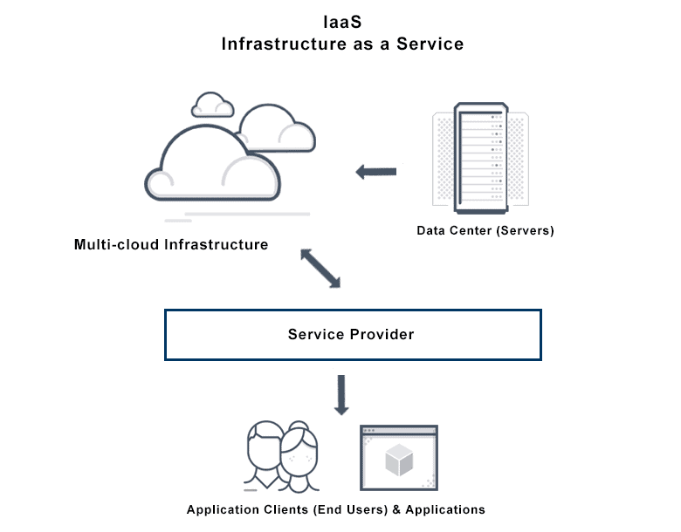

Why is Infrastructure as a Service important?

You can use IaaS to scale your compute capacity while reducing your IT expenditure. Traditionally, enterprises purchased and maintained their own computing devices in an on-premises data center. However, this often required a heavy up-front investment to handle only occasionally high workloads. For example, an e-commerce company gets three times more application traffic during the holiday season. To handle this traffic, they have to purchase additional server machines, which remain idle for the rest of the year.

To overcome this challenge, cloud providers like AWS maintain highly secure data centers with a large volume of hardware devices. They give you access to this cloud computing infrastructure on a pay-as-you-go basis. You get flexible and secure access to practically unlimited resources so that you can meet all your business, legal, and compliance requirements.

## What are the benefits of Infrastructure as a Service?

IaaS offers benefits to modern enterprises like the following:

### **Speed**

You can provision any number of resources within minutes, testing, and launching new ideas to market much faster. You can focus on your core business activities because others fully manage the IT infrastructure and computing resources.

### **Performance**

Cloud providers have geographically distributed data centers that you can use to scale up your applications in locations that are physically closer to your customers. This might not be possible on your own if you have a limited server capacity and geographic reach. IaaS solutions give you a lot more options that you can use to both increase compute performance and reduce network latency.

### **Reliability**

IaaS providers, such as AWS, offer a highly reliable environment where replacement virtual machines can be rapidly and predictably commissioned. The service runs within Amazon’s proven network infrastructure and data centers. For example, the Amazon EC2 Service Level Agreement commitment is 99.99% availability for each Amazon EC2 Region.

### **Back up and recovery**

IaaS providers give you access to unlimited infrastructure for backup and disaster recovery. For example, you can duplicate your applications across multiple servers so that if one fails, another takes over. Similarly, you can sync data backups automatically and frequently to achieve redundancy and business continuity

### **Competitive pricing**

IaaS is a cloud computing model in which customers pay only for the resources they use. Such a setup encourages more efficient IT resource management and promotes innovation by making cloud services affordable to small businesses.

What are the use cases of Infrastructure as a Service?

You can use cloud infrastructure to improve operational efficiency and prioritize solution delivery over infrastructure management. An IaaS provider can support you to improve customer experience with high-performing, fully managed infrastructure. Let’s look at some example use cases below.

High performance computing

Complex problems like analyzing large volumes of data or solving physics and chemistry equations require significant computational power. It is more efficient and cost-effective to solve these problems on IaaS infrastructure instead of running your own resources.

Website hosting

Organizations use cloud infrastructure to host high performing web applications that are secure, scalable, and fully customizable to meet their content delivery needs. For example, Amazon Web Services (AWS) offers low-cost [web hosting solutions](https://aws.amazon.com/websites/) that you can use to build a range of websites, from simple information sites to complex data delivery systems.

Big data analytics

Companies analyze data to derive business intelligence and actionable insights. Cloud infrastructure includes data warehousing technology to store large volumes of data in an integrated way. An IaaS provider supports [big data analytics](https://aws.amazon.com/big-data/datalakes-and-analytics/) by providing cloud computing services that you can use to manage data more efficiently.

App development

You can use cloud infrastructure to quickly set up separate test and development environments. You can experiment and test new ideas in isolation or create common development environments for the whole team.

## How does Infrastructure as a Service work?

IaaS works on the principle of virtualization. An IaaS platform lets you select the type and configuration of the infrastructure you require. The system then automatically creates digital versions of the underlying infrastructure. These virtualized computing resources mimic the behavior of physical resources. For you and your applications, everything works the same as it would on a physical device.

I​​aaS providers also offer additional services to support infrastructure management. For example, you can use the services to do these tasks:

* View system logs and monitor performance
* Implement consistent security measures across all your infrastructure
* Configure policies that automate common infrastructure tasks, like backup and load balancing

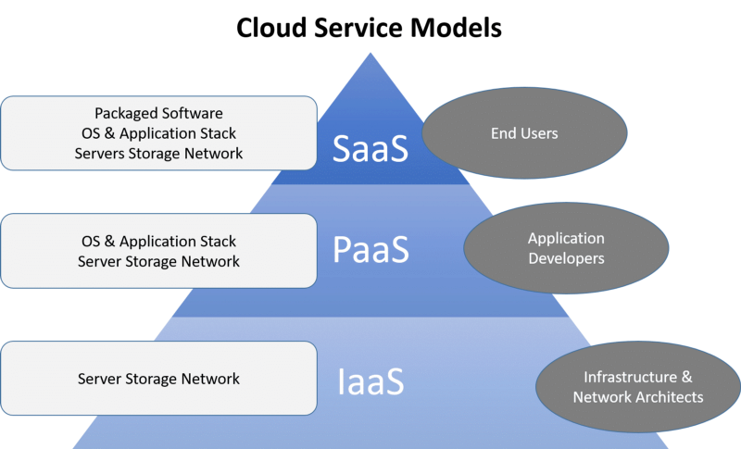

**Software as a Service in Cloud Computing.**

What is SaaS?

Software as a service (or SaaS) is a way of delivering applications over the Internet—as a service. Instead of installing and maintaining software, you simply access it via the Internet, freeing yourself from complex software and hardware management.

SaaS applications are sometimes called Web-based software, on-demand software, or hosted software. Whatever the name, SaaS applications run on a SaaS provider’s servers. The provider manages access to the application, including security, availability, and performance.

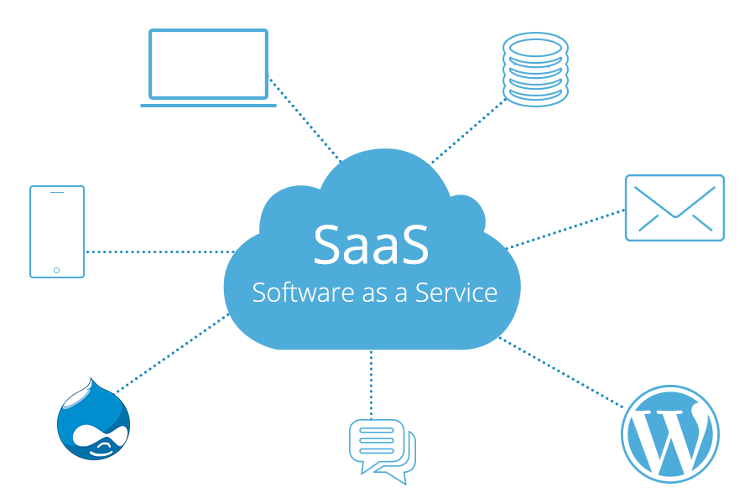

SaaS Characteristics

A good way to understand the SaaS model is by thinking of a bank, which protects the privacy of each customer while providing service that is reliable and secure—on a massive scale. A bank’s customers all use the same financial systems and technology without worrying about anyone accessing their personal information without authorisation.

A “bank” meets the key characteristics of the SaaS model:

Multitenant Architecture

A multitenant architecture, in which all users and applications share a single, common infrastructure and code base that is centrally maintained. Because SaaS vendor clients are all on the same infrastructure and code base, vendors can innovate more quickly and save the valuable development time previously spent on maintaining numerous versions of outdated code.

Easy Customisation

The ability for each user to easily customise applications to fit their business processes without affecting the common infrastructure. Because of the way SaaS is architected, these customisations are unique to each company or user and are always preserved through upgrades. That means SaaS providers can make upgrades more often, with less customer risk and much lower adoption cost.

Better Access

Improved access to data from any networked device while making it easier to manage privileges, monitor data use, and ensure everyone sees the same information at the same time.

SaaS Harnesses the Consumer Web

Anyone familiar with Amazon.com or My Yahoo! will be familiar with the Web interface of typical SaaS applications. With the SaaS model, you can customise with point-and-click ease, making the weeks or months it takes to update traditional business software seem hopelessly old fashioned.

SaaS Trends

Organisations are now developing SaaS integration platforms (or SIPs) for building additional SaaS applications. The consulting firm Saugatuck Technology calls this the “third wave” in software adoption: when SaaS moves beyond standalone software functionality to become a platform for mission-critical applications.

SaaS is one of several cloud computing solutions for business IT issues. Other ‘as-a-Service’ options include:

Infrastructure as a Service (IaaS) – the provider hosts hardware, software, storage and other infrastructure component

Platform as a Service (PaaS)

Everything as a service (XaaS) – which is essentially all the "aaS" tools neatly packaged together.

The payment model for these kinds of services is typically a per-seat, per-month charge based on usage – so a business only has to pay for what they need, reducing upfront costs

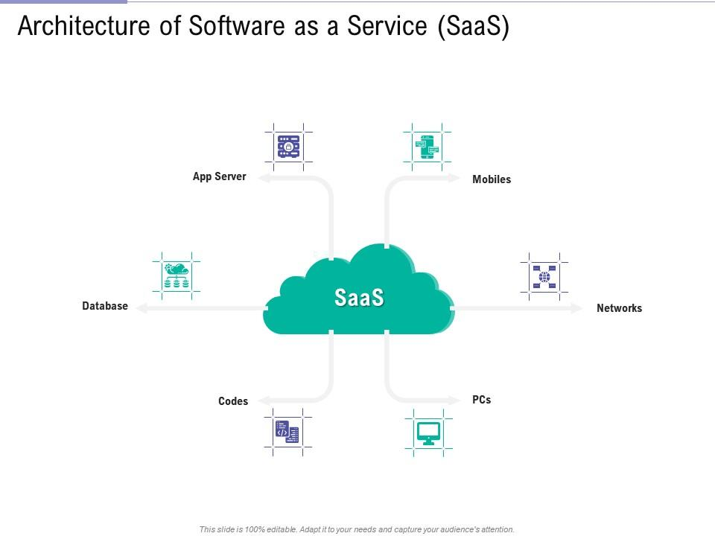

The benefits of SaaS

Increased efficiency and cost effectiveness are the reasons many businesses give for turning to cloud-based SaaS solutions. The advantages include:

Low setup and infrastructure costs  
You just pay for what you need with no capital expenditure that needs to be depreciated on your balance sheet over time.

Accessible from anywhere  
Just connect to the internet and you can work from wherever you need to be via desktop, laptop, tablet or mobile or other networked device.

Scalability  
You can adapt your requirements to the number of people who need to use the system, the volume of data and the functionality required as your business grows.

Industry leading service level agreements (SLAS) for uptime and performance  
So you have assurances that the software will be available to use when you need it – a difficult promise for in-house teams to make.

Automatic, frequent updates  
Providers offer timely improvements thanks to their scale and because they receive feedback about what their customers need. This frees up your IT department for other more business-critical tasks.

Security at the highest level required by any customer  
Because of the shared nature of the service, all users benefit from the security level that’s been set up for those with the highest need.

**Major public clouds: Google cloud,**

**Google Cloud Platform** (**GCP**), offered by [Google](https://en.wikipedia.org/wiki/Google), is a suite of [cloud computing](https://en.wikipedia.org/wiki/Cloud_computing) services that runs on the same infrastructure that Google uses internally for its end-user products, such as [Google Search](https://en.wikipedia.org/wiki/Google_Search), [Gmail](https://en.wikipedia.org/wiki/Gmail), [Google Drive](https://en.wikipedia.org/wiki/Google_Drive), and [YouTube](https://en.wikipedia.org/wiki/YouTube).[[2]](https://en.wikipedia.org/wiki/Google_Cloud_Platform#cite_note-2)[[*disputed*](https://en.wikipedia.org/wiki/Wikipedia:Disputed_statement)*–*[*discuss*](https://en.wikipedia.org/wiki/Talk:Google_Cloud_Platform)] Alongside a set of management tools, it provides a series of modular cloud services including computing, [data storage](https://en.wikipedia.org/wiki/Computer_data_storage), [data analytics](https://en.wikipedia.org/wiki/Data_analysis) and [machine learning](https://en.wikipedia.org/wiki/Machine_learning).[[3]](https://en.wikipedia.org/wiki/Google_Cloud_Platform#cite_note-auto-3) Registration requires a [credit card](https://en.wikipedia.org/wiki/Credit_card) or bank account details.[[4]](https://en.wikipedia.org/wiki/Google_Cloud_Platform#cite_note-4)

Google Cloud Platform provides [infrastructure as a service](https://en.wikipedia.org/wiki/Infrastructure_as_a_service), [platform as a service](https://en.wikipedia.org/wiki/Platform_as_a_service), and [serverless computing](https://en.wikipedia.org/wiki/Serverless_computing" \o "Serverless computing) environments

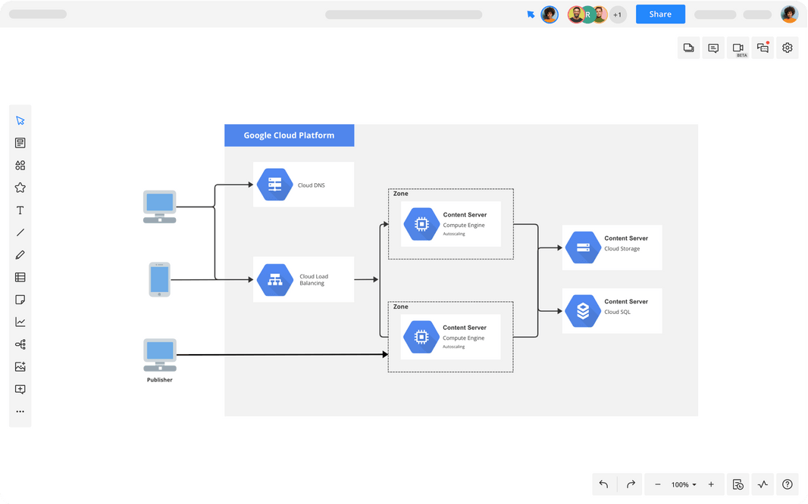

Google Cloud: Pros and cons

As a latecomer to the cloud market, Google Cloud Platform (GCP) naturally offers a more limited range of services and doesn’t command the same global spread of data centers offered by AWS and Azure.

It does, however, give customers a highly specialized service in three main streams: big data, machine learning, and analytics, with good scale and stable load balancing, as well as those famously low response times.

Google’s container offering provides users with a significant advantage as it developed the very Kubernetes standard now utilized by competitors AWS and Azure.

Customers tend to choose GCP as a secondary vendor in a hybrid solution, though it is becoming increasingly popular with organizations that are direct competitors with Amazon, and therefore cannot use AWS.

It’s important to note that GCP is very open-source- and DevOps-centric, and as a result does not integrate as well with Microsoft Azure.

|  |  |
| --- | --- |
| **Strengths** | **Weaknesses** |
| Excellent integration with other Google services | Majority of components based on Google proprietary tech; no real control over Virtual Machines |
| Fast I/O | Limited choice of programming languages |
| Strong data analytics and storage | Complex transition away from the platform to another vendor |
| Facilitates easy collaboration | Fewer features/services |
| Designed for cloud-native business | Fewer global data centers |
| Good portability and open source integration |  |

**AWS,**

## What is AWS?

The full form of AWS is Amazon Web Services. It is a platform that offers flexible, reliable, scalable, easy-to-use and, cost-effective cloud computing solutions.

AWS is a comprehensive, easy to use computing platform offered Amazon. The platform is developed with a combination of infrastructure as a service (IaaS), platform as a service (PaaS) and packaged software as a service (SaaS) offerings.

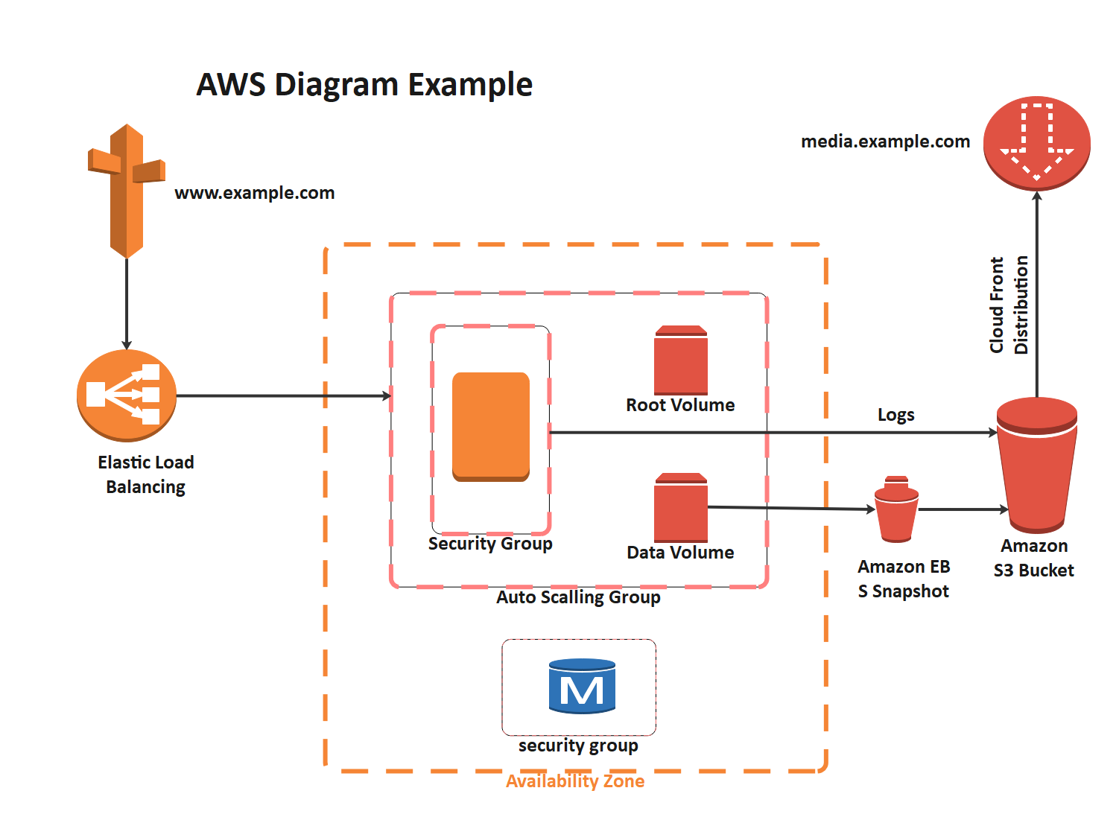

|  |  |
| --- | --- |
| **Strengths** | **Weaknesses** |
| Extensive range of infrastructure applications | Range of infrastructure options can be overwhelming for more traditional enterprises |
| Highly flexible | Hybrid options available, but not a priority |
| Easy transition for users with existing digital infrastructure | Organizations operating on legacy systems may experience longer migration times |
| Frequently updated and maintained |  |
| Free tier available |  |
| Greater control over security |  |
| Scalability |  |
| Cost-effective pricing model |  |
| Rapid deployment |  |
| Support for large enterprises |  |

## What is Microsoft Azure?

[Azure is a cloud computing platform](https://www.simplilearn.com/azure-cloud-services-and-its-importance-article?source=frs_author_page) and an online portal that allows you to access and manage cloud services and resources provided by Microsoft. These services and resources include storing your data and transforming it, depending on your requirements. To get access to these resources and services, all you need to have is an active internet connection and the ability to connect to the Azure portal

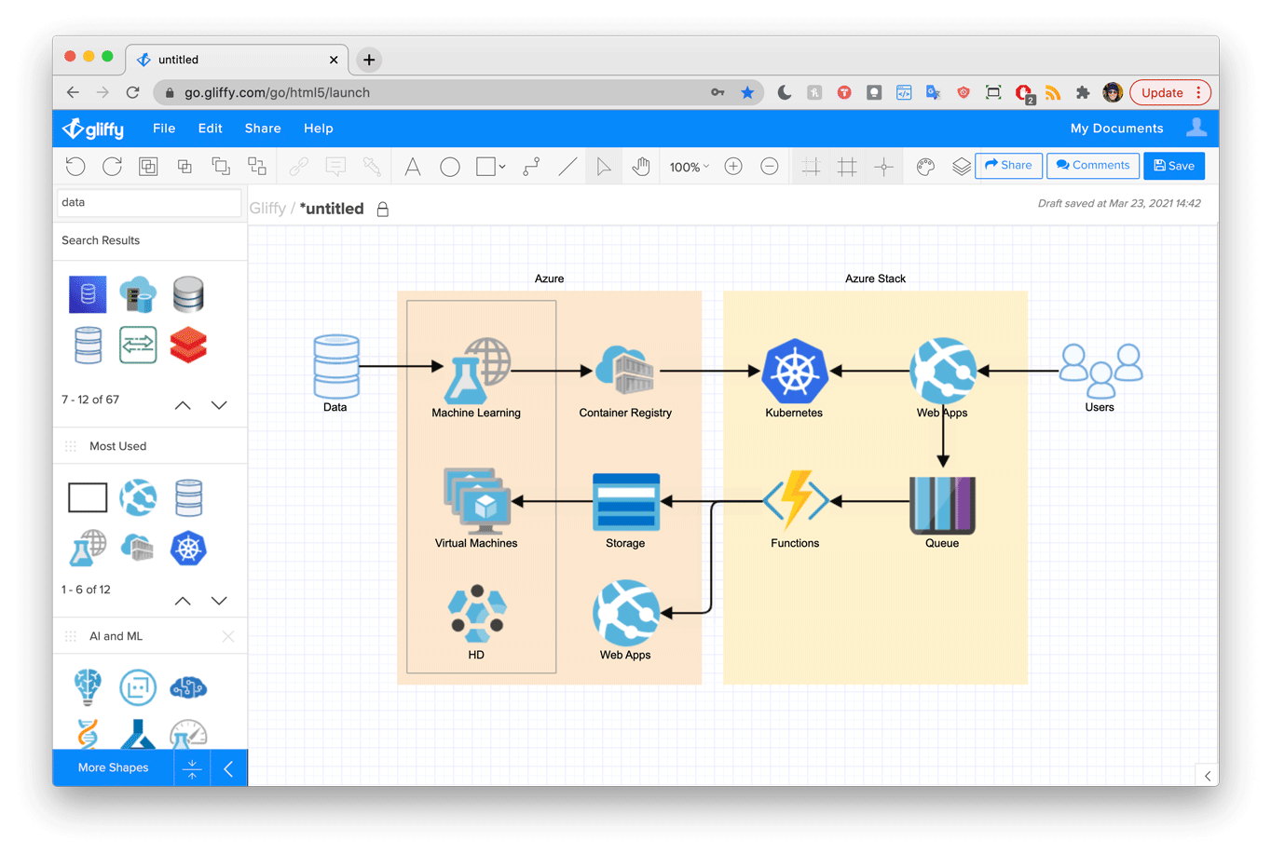

Microsoft Azure: Pros and cons

Microsoft showed up on the cloud scene a little later than AWS, but certainly made up for it by adapting its existing on-premises offerings (e.g. Windows Server, Office, SQL Server, SharePoint, Dynamics, etc.) for the cloud.

Over a decade since its initial launch, Azure is a strong competitor to AWS, providing businesses with a great range of features, robust open-source support, and straightforward integration with other Microsoft tools. This makes it particularly well suited for Microsoft-centric organizations.

As a Microsoft product, Azure no doubt benefits from user familiarity with the brand, which creates an immediate preference for Azure among loyal Microsoft customers.

While Azure has an investment focus on making architectural improvements and providing a broad range of enterprise-focused services, in its aforementioned Magic Quadrant report, Gartner noted that “Azure’s novel innovations in the market for IaaS and PaaS relative to its competitors over the past year were substantially less appealing.

Additionally, despite Microsoft Azure’s beginnings as an application PaaS provider, Azure’s product execution and adoption in this segment have been rather mixed.”

Users raised concerns surrounding the resiliency of critical services and the real-world impacts of these services being unavailable. Elsewhere, users also cited issues with commercial complexity and technical support as some primary pain-points when using the provider.

|  |  |
| --- | --- |
| **Strengths** | **Weaknesses** |
| High availability | Requires considerable management |
| Strong focus on Security | Requires platform expertise |
| Scalability | More limited backward compatibility |
| Cost-effective | Comparatively more costly than other leading vendors |
| Strong IaaS and PaaS options | Additional charge for pay-as-you-go option |
| Support for open source | Customer service |
| Hybrid cloud |  |

The below table shows the difference between AWS, Azure, and Google Cloud Platform -

|  |  |  |  |
| --- | --- | --- | --- |
| **Parameter** | **AWS** | **Azure** | **Google Cloud Platform** |
| **App Testing** | It uses device farm | It uses DevTest labs | It uses Cloud Test labs. |
| **API Management** | Amazon API gateway | Azure API gateway | Cloud endpoints. |
| **Kubernetes Management** | EKS | Kubernetes service | Kubernetes engine |
| **Git Repositories** | AWS source repositories | Azure source repositories | Cloud source repositories. |
| **Data warehouse** | Redshift | SQL warehouse | Big Query |
| **Object Storage** | S3 | Block Blobs and files | Google cloud storage. |
| **Relational DB** | RDS | Relational DBs | Google Cloud SQL |
| **Block Storage** | EBS | Page Blobs | Persistent disks |
| **Marketplace** | AWS | Azure | G suite |
| **File Storage** | EFS | Azure Files | ZFS and Avere |
| **Media Services** | Amazon Elastic transcoder | Azure media services | Cloud video intelligence API |
| **Virtual network** | VPC | VNet | Subnet |
| **Pricing** | Per hour | Per minute | Per minute |
| **Maximum processors in VM** | 128 | 128 | 96 |
| **Maximum memory in VM (GiB)** | 3904 | 3800 | 1433 |
| **Catching** | ElasticCache | RedisCache | CloudCDN |
| **Load Balancing Configuration** | Elastic Load Balancing | Load Balancer Application Gateway | Cloud Load Balancing |
| **Global Content Delivery Networks** | CloudFront | Content Delivery Network | Cloud Interconnect |

**Application development and deployment in cloud - Dockers,**

Docker is a software platform that allows you to build, test, and deploy applications quickly. Docker packages software into standardized units called [containers](https://aws.amazon.com/containers/) that have everything the software needs to run including libraries, system tools, code, and runtime. Using Docker, you can quickly deploy and scale applications into any environment and know your code will run.

Running Docker on AWS provides developers and admins a highly reliable, low-cost way to build, ship, and run distributed applications at any scale.

## How Docker works

Docker works by providing a standard way to run your code. Docker is an operating system for containers. Similar to how a [virtual machine](https://aws.amazon.com/ec2/) virtualizes (removes the need to directly manage) server hardware, containers virtualize the operating system of a server. Docker is installed on each server and provides simple commands you can use to build, start, or stop containers.

AWS services such as [AWS Fargate](https://aws.amazon.com/fargate/), [Amazon ECS](https://aws.amazon.com/ecs/), [Amazon EKS](https://aws.amazon.com/eks/), and [AWS Batch](https://aws.amazon.com/batch/) make it easy to run and manage Docker containers at scale.

Why use Docker

Using Docker lets you ship code faster, standardize application operations, seamlessly move code, and save money by improving resource utilization. With Docker, you get a single object that can reliably run anywhere. Docker's simple and straightforward syntax gives you full control. Wide adoption means there's a robust ecosystem of tools and off-the-shelf applications that are ready to use with Docker.



SHIP MORE SOFTWARE FASTER

Docker users on average ship software 7x more frequently than non-Docker users. Docker enables you to ship isolated services as often as needed.



STANDARDIZE OPERATIONS

Small containerized applications make it easy to deploy, identify issues, and roll back for remediation.

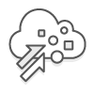

SEAMLESSLY MOVE

Docker-based applications can be seamlessly moved from local development machines to production deployments on AWS.



SAVE MONEY

Docker containers make it easier to run more code on each server, improving your utilization and saving you money.

When to use Docker

You can use Docker containers as a core building block creating modern applications and platforms. Docker makes it easy to build and run distributed microservices architecures, deploy your code with standardized continuous integration and delivery pipelines, build highly-scalable data processing systems, and create fully-managed platforms for your developers. The recent collaboration between AWS and Docker makes it easier for you to deploy Docker Compose artifacts to Amazon ECS and AWS Fargate.

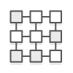

MICROSERVICES

Build and scale distributed application architectures by taking advantage of standardized code deployments using Docker containers.



CONTINUOUS INTEGRATION & DELIVERY

Accelerate application delivery by standardizing environments and removing conflicts between language stacks and versions.



DATA PROCESSING

Provide big data processing as a service. Package data and analytics packages into portable containers that can be executed by non-technical users.



CONTAINERS AS A SERVICE

Build and ship distributed applications with content and infrastructure that is IT-managed and secured

**microservices,**

# **What are microservices?**

Microservices - also known as the microservice architecture - is an architectural style that structures an application as a collection of services that are

* Independently deployable
* Loosely coupled
* Organized around business capabilities
* Owned by a small team
* Highly maintainable and testable

The microservice architecture enables the rapid, frequent and reliable delivery of large, complex applications. It also enables an organization to evolve its technology stack.

## Benefits[[edit](https://en.wikipedia.org/w/index.php?title=Microservices&action=edit&section=4" \o "Edit section: Benefits)]

The benefit of decomposing an application into different smaller services are numerous:

* [Modularity](https://en.wikipedia.org/wiki/Modular_programming): This makes the application easier to understand, develop, test, and become more resilient to architecture erosion.[[6]](https://en.wikipedia.org/wiki/Microservices#cite_note-Micro_Chen-6) This benefit is often argued in comparison to the complexity of monolithic architectures.[[35]](https://en.wikipedia.org/wiki/Microservices#cite_note-35)
* [Scalability](https://en.wikipedia.org/wiki/Scalability): Since microservices are implemented and deployed independently of each other, i.e. they run within independent processes, they can be monitored and scaled independently.[[36]](https://en.wikipedia.org/wiki/Microservices#cite_note-36)
* [Integration](https://en.wikipedia.org/wiki/System_integration) of heterogeneous and [legacy systems](https://en.wikipedia.org/wiki/Legacy_system): microservices is considered a viable means for modernizing existing monolithic software application.[[37]](https://en.wikipedia.org/wiki/Microservices#cite_note-37)[[38]](https://en.wikipedia.org/wiki/Microservices#cite_note-38) There are experience reports of several companies who have successfully replaced (parts of) their existing software with microservices or are in the process of doing so.[[39]](https://en.wikipedia.org/wiki/Microservices#cite_note-39) The process for [Software modernization](https://en.wikipedia.org/wiki/Software_modernization) of legacy applications is done using an incremental approach.[[40]](https://en.wikipedia.org/wiki/Microservices#cite_note-researchgate.net-40)
* Distributed development: it parallelizes [development](https://en.wikipedia.org/wiki/Software_development) by enabling small autonomous teams to develop, [deploy](https://en.wikipedia.org/wiki/Software_deployment) and scale their respective services independently.[[41]](https://en.wikipedia.org/wiki/Microservices#cite_note-41) It also allows the architecture of an individual service to emerge through continuous [refactoring](https://en.wikipedia.org/wiki/Refactoring).[[42]](https://en.wikipedia.org/wiki/Microservices#cite_note-Ach_Chen-42) Microservice-based architectures facilitate [continuous integration](https://en.wikipedia.org/wiki/Continuous_integration), [continuous delivery](https://en.wikipedia.org/wiki/Continuous_delivery) and deployment

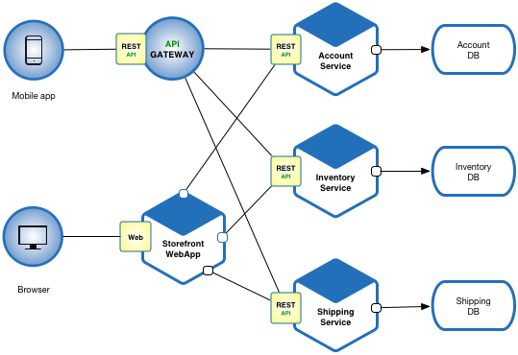

**Kubernetes,**

# **What is Kubernetes?**

Kubernetes, often abbreviated as “K8s”, orchestrates [containerized](https://tanzu.vmware.com/containers) applications to run on a cluster of hosts. The K8s system automates the deployment and management of [cloud native](https://tanzu.vmware.com/cloud-native) applications using on-premises infrastructure or public cloud platforms. It distributes application workloads across a [Kubernetes cluster](https://www.vmware.com/topics/glossary/content/kubernetes-cluster.html" \t "_blank) and automates dynamic container networking needs. Kubernetes also allocates storage and persistent volumes to running containers, provides automatic scaling, and works continuously to maintain the desired state of applications, providing resiliency.

## Kubernetes Features

Kubernetes has many features that help orchestrate containers across multiple hosts, automate the management of K8s clusters, and maximize resource usage through better utilization of infrastructure. Important features include:

* **Auto-scaling**. Automatically scale containerized applications and their resources up or down based on usage
* **Lifecycle management**. Automate deployments and updates with the ability to:
  + Rollback to previous versions
  + Pause and continue a deployment
* **Declarative model**. Declare the desired state, and K8s works in the background to maintain that state and recover from any failures
* **Resilience and self-healing**. Auto placement, auto restart, auto replication and auto scaling provide application self-healing
* **Persistent storage**. Ability to mount and add storage dynamically
* **Load balancing**. Kubernetes supports a variety of internal and external load balancing options to address diverse needs
* **DevSecOps support**. [DevSecOps](https://tanzu.vmware.com/devsecops" \t "_blank) is an advanced approach to security that simplifies and automates container operations across clouds, integrates security throughout the container lifecycle, and enables teams to deliver secure, high-quality software more quickly. Combining DevSecOps practices and Kubernetes improves developer productivity.

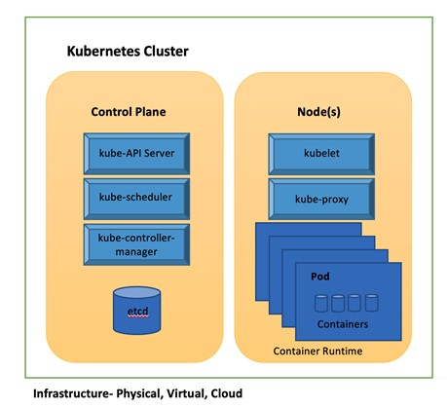

## Kubernetes Advantages

The Kubernetes platform has become popular because it provides a number of important advantages:

* **Portability.** Containers are portable across a range of environments from virtual environments to bare metal. Kubernetes is supported in all major public clouds, as a result, you can run containerized applications on K8s across many different environments.
* **Integration and extensibility**. Kubernetes is extensible to work with the solutions you already rely on, including logging, monitoring, and alerting services. The Kubernetes community is working on a variety of open source solutions complementary to Kubernetes, creating a rich and fast-growing ecosystem.
* **Cost efficiency**. Kubernetes' inherent resource optimization, automated scaling, and flexibility to run workloads where they provide the most value means your IT spend is in your control.
* **Scalability**. Cloud native applications scale horizontally. Kubernetes uses “auto-scaling,” spinning up additional container instances and scaling out automatically in response to demand.
* **API-based**. The fundamental fabric of Kubernetes is its REST API. Everything in the Kubernetes environment can be controlled through programming.
* **Simplified CI/CD**. [CI/CD](https://tanzu.vmware.com/cicd) is a DevOps practice that automates building, testing and deploying applications to production environments. Enterprises are integrating Kubernetes and CI/CD to create scalable CI/CD pipelines that adapt dynamically to load.

**Server less.**

Serverless is a [cloud-native](https://www.redhat.com/en/topics/cloud-native-apps) development model that allows developers to build and run applications without having to manage servers.

There are still servers in serverless, but they are abstracted away from app development. A [cloud provider](https://www.redhat.com/en/topics/cloud-computing/what-are-cloud-providers) handles the routine work of [provisioning](https://www.redhat.com/en/topics/automation/what-is-provisioning), maintaining, and scaling the server [infrastructure](https://www.redhat.com/en/topics/cloud-computing/what-is-it-infrastructure). Developers can simply package their code in [containers](https://www.redhat.com/en/topics/containers) for deployment.

Once deployed, serverless apps respond to demand and [automatically](https://www.redhat.com/en/topics/automation) scale up and down as needed. Serverless offerings from [public cloud](https://www.redhat.com/en/topics/cloud-computing/what-is-public-cloud) providers are usually metered on-demand through an [event-driven](https://www.redhat.com/en/topics/integration/what-is-event-driven-architecture) execution model. As a result, when a serverless function is sitting idle, it doesn’t cost anything.

## What is the cloud provider’s role in serverless computing?

Under a serverless model, a cloud provider runs physical servers and dynamically allocates their resources on behalf of users who can deploy code straight into production.

Serverless computing offerings typically fall into two groups, Backend-as-a-Service (BaaS) and [Function-as-a-Service (FaaS)](https://www.redhat.com/en/topics/cloud-native-apps/what-is-faas).

BaaS gives developers access to a variety of third-party services and apps. For instance, a cloud-provider may offer authentication services, extra encryption, cloud-accessible databases, and high-fidelity usage data. With BaaS, serverless functions are usually called through [application programming interfaces (APIs)](https://www.redhat.com/en/topics/api/what-are-application-programming-interfaces).

More commonly, when developers refer to serverless, they’re talking about a FaaS model. Under FaaS, developers still write custom server-side logic, but it’s run in containers fully managed by a cloud services provider.

The major public cloud providers all have one or more FaaS offerings. They include [Amazon Web Services](https://www.redhat.com/en/partners/aws) with AWS Lambda, [Microsoft Azure](https://www.redhat.com/en/partners/microsoft) with Azure Functions, [Google Cloud](https://www.redhat.com/en/partners/google) with multiple offerings, and [IBM Cloud](https://www.redhat.com/en/partners/ibm-alliance) with IBM Cloud Functions, among others.

Some organizations choose to operate their own FaaS environments using open source serverless platforms, including [Red Hat® OpenShift® Serverless](https://www.redhat.com/en/topics/microservices/why-choose-openshift-serverless), which is built on the [Knative](https://www.redhat.com/en/topics/microservices/what-is-knative) project for [Kubernetes](https://www.redhat.com/en/topics/containers/what-is-kubernetes).

## What are the pros and cons of serverless computing?

**Pros**

* Serverless computing can increase developer productivity and reduce operational costs. By offloading the routine tasks of provisioning and managing servers, developers have more time to focus on their apps.
* Serverless helps enable [DevOps](https://www.redhat.com/en/topics/devops) adoption by reducing the need for developers to explicitly describe the infrastructure they need operations to provision for them.
* It’s possible to streamline app development even further by incorporating entire components from third-party BaaS offerings.
* Operational costs are reduced in a serverless model because you can pay for cloud-based compute time as it’s needed, as opposed to running and managing your own servers all the time.

**Cons**

* Not running your own server or controlling your own server-side logic can have drawbacks.
* Cloud providers may have strict constraints on how their components can be interacted with, in turn affecting how flexible and customized your own systems can be. In the case of BaaS environments, developers may be beholden to services whose code is outside their control.
* Ceding control of these aspects of your IT stack also opens you up to vendor lock-in. Deciding to change providers will also likely come with the cost of upgrading your systems to adhere to the new vendor’s specifications.

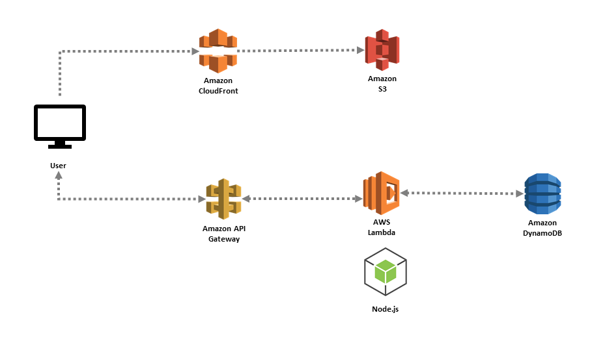

**Continuous Integration/Continuous Delivery**

CodePipeline is a continuous delivery service that automates the building, testing, and deployment of your software into production.

[Continuous delivery](https://aws.amazon.com/devops/continuous-delivery/) is a software development methodology where the release process is automated. Every software change is automatically built, tested, and deployed to production. Before the final push to production, a person, an automated test, or a business rule decides when the final push should occur. Although every successful software change can be immediately released to production with continuous delivery, not all changes need to be released right away.

[Continuous integration](https://aws.amazon.com/devops/continuous-integration/) is a software development practice where members of a team use a version control system and frequently integrate their work to the same location, such as a main branch. Each change is built and verified to detect integration errors as quickly as possible. Continuous integration is focused on automatically building and testing code, as compared to continuous delivery, which automates the entire software release process up to production.

